**Lswork**

**1.User Role** **3**

Rosa 3

Jane 3

Chris 3

Admin 3

2.Website **4**

2.1 Step of applying a form using Lswork webapp 4

2.2. Steps of approve form 12

2.3 Step of Finance approve 16

**3. Android** **19**

3.1 Go to Website 19

# 1.User Role

## Rosa

Username:rosa

Password:1

Position:Normal Staff

## Jane

Username:jane

Password:1

Position:rosa header and approver

## Chris

Username:chris

Password:1

Position:Finance approver

## Admin

Username:admin

Password:1

# 2.Website

## 2.1 Step of applying a form using Lswork webapp

**1. Go to our demo site. Link:** [**https://demo.lsworkapp.com**](https://demo.lsworkapp.com)

**Now we will use Rosa Khoury Gebrail’s account to submit a form to Jane Webster. Chris Mottram will be the final approver.**

**2. Login to Your account**

**Username: rosa**

**Password: 1**

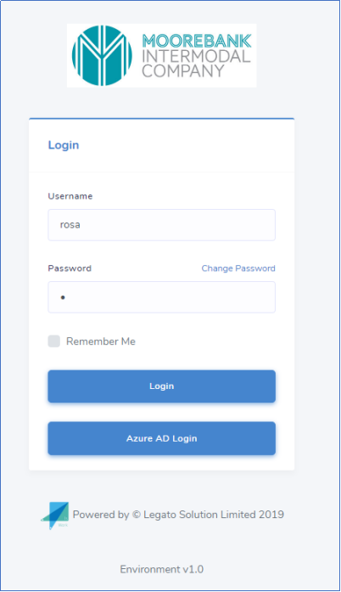

**3. Open Form and click new form**

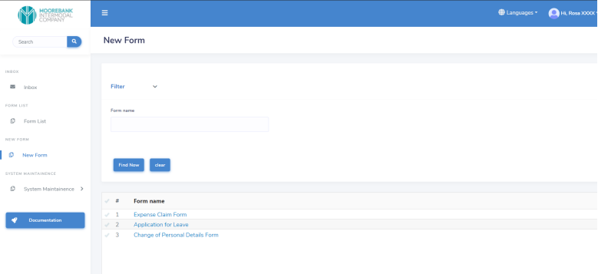

**4. Choose the form you want to create. In this demo we will create Expense Claim Form.**

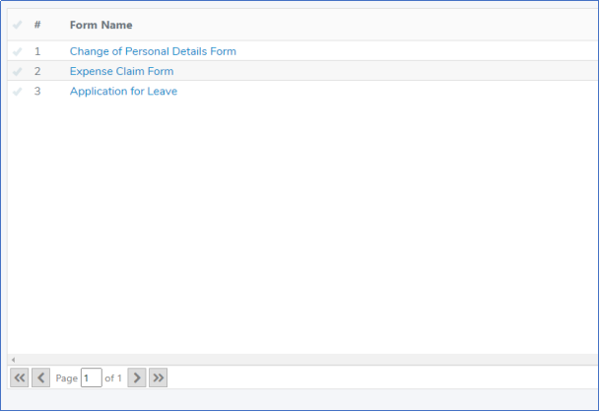

**5. Fill in the form and then click Save button**

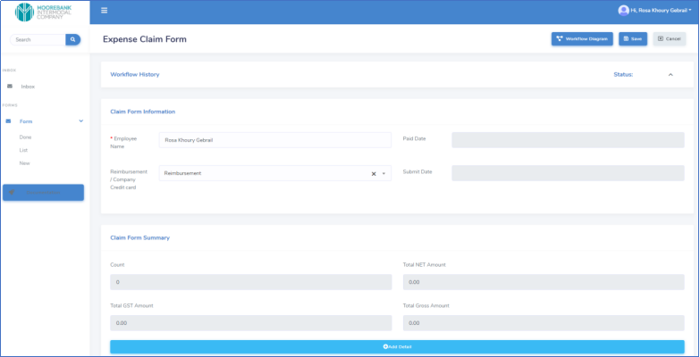

**6. You can see the workflow by clicking the Workflow Diagram button**

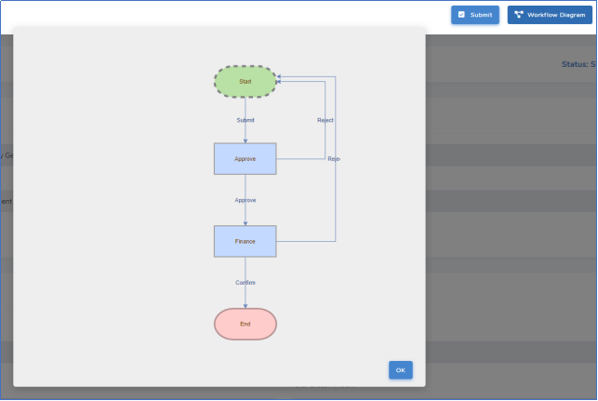

**7. After that, you can submit the form and choose the approver**

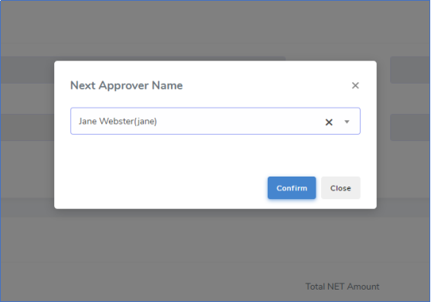

**8. Then, you can open the Workflow History. You will see all the action detail on your form.**

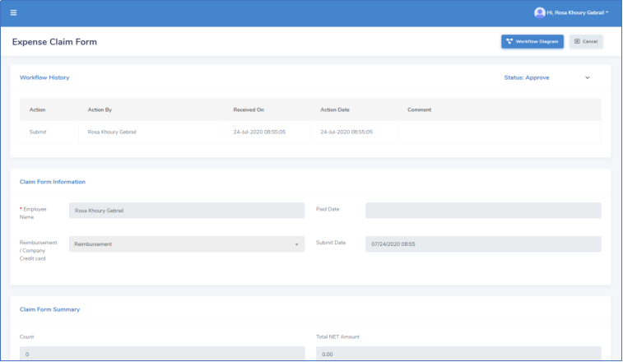

## 2.2. Steps of approve form

**1. Login in to approve’s account**

**Username: jane**

**Password: 1**

**2. You can see the forms submitted to you in the InBox**

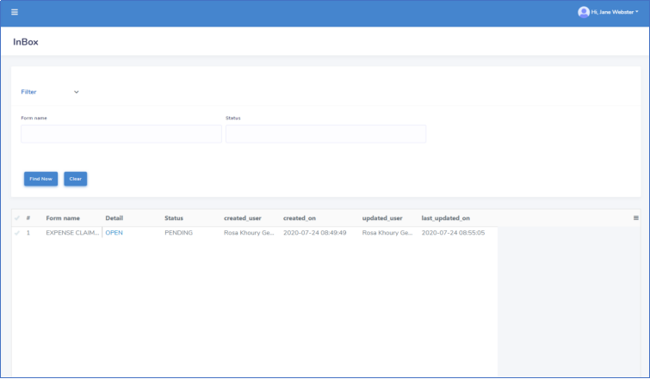

**3. Click the OPEN button in the form list, you can see the detail of the form**

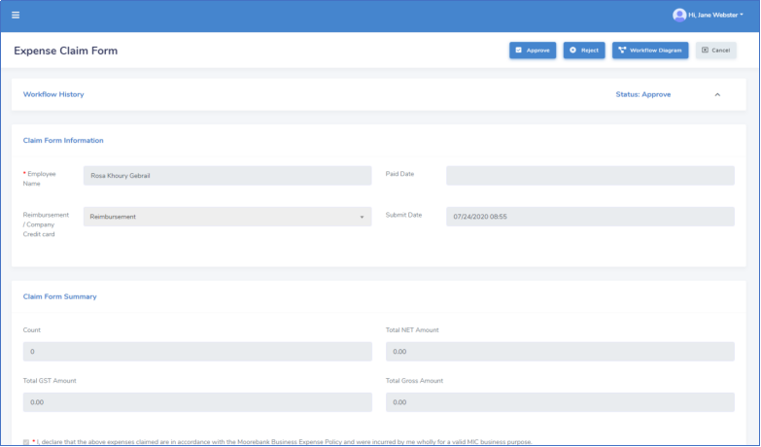

**4. When you click the Workflow Diagram, you can see who submit the form to you**

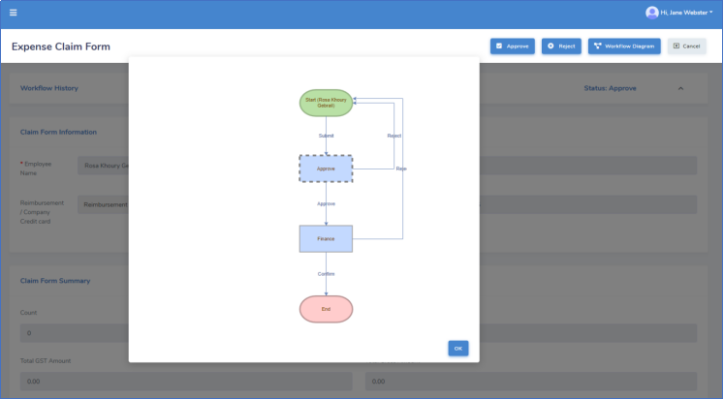

**5. When you want to approve the form application, click the approve button, otherwise click the reject button.**

**6. Then you need to choose the next approver**

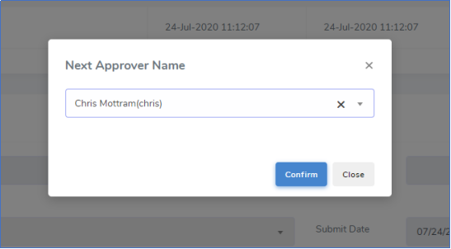

**7. You can also open the Workflow history and Workflow diagram to see the form action detail.**

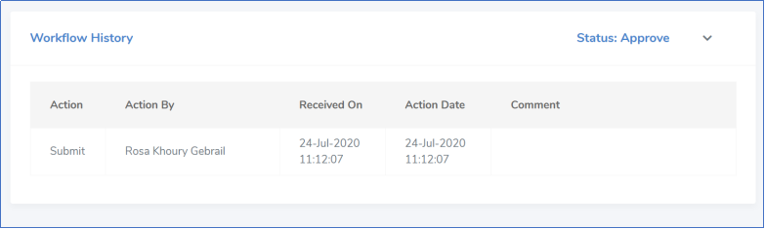

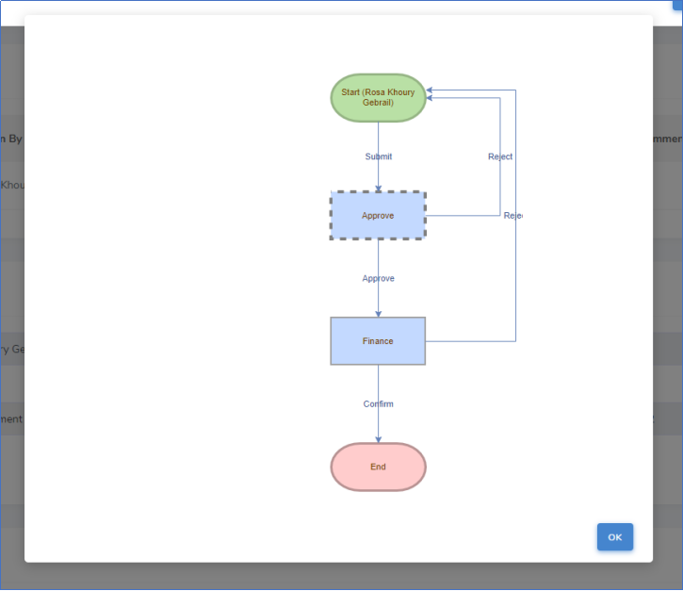

## 2.3 Step of Finance approve

**1. Login to finance account**

**Username: chris**

**Password: 1**

**2. You can see the form in the InBox**

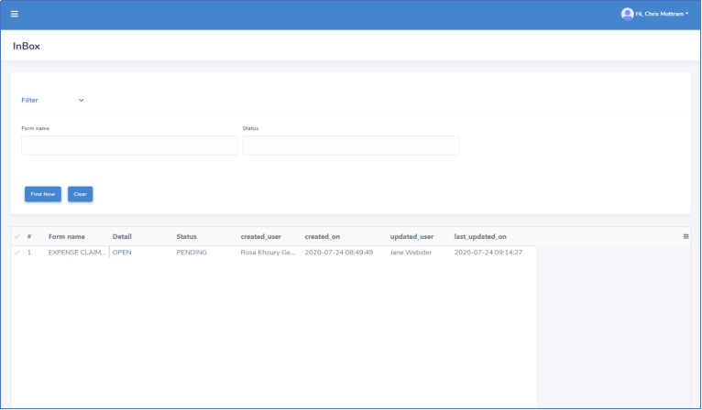

**3. You can see the detail of the form**

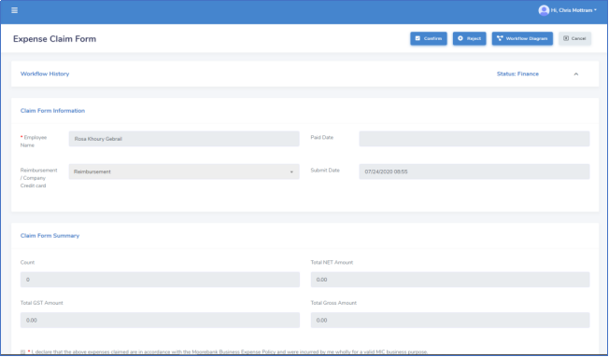

**4. After you click confirm, the whole application process is finished.**

**The applicant can see his application form in Done column after the whole application process is finished.**

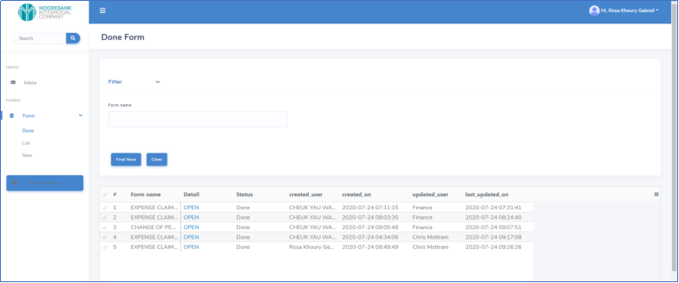

# 3. Android

## 3.1 Go to Website

<https://www.lsworkapp.com/>

1.Click the Get it for Andriod

