**Lswork**

**Menu**

**1 General** **4**

1.1 Filter 4

**2 Personal Details** **4**

2.1Login 4

2.1.1Normal Login : 4

2.1.2Azure Login : 5

2.2 Logout 7

2.3 Change Account Detail 7

2.3.1 General Detail 7

2.3.2 Change Password 8

2.3.3 Change username 9

**3 Builder** **9**

3.1 Database Model 9

3.1.1 Create Model 9

3.2 Workflow 10

3.2.1 create new workflow 10

3.3 Form Builder 11

**4 System Maintenance** **11**

4.1 Email Template 11

4.2 Company Logo 12

4.3 Staff Relationship 13

4.4 Role Access 14

4.5 Roles 15

4.6 Staff Annual Leave 16

4.7 System Parameter 17

4.8 System Word 19

4.9 User 19

**5. Test Case** **22**

5.1 Step of applying a form using Lswork webapp 22

5.2. Steps of approve form 30

5.3 Step of Finance approve 34

# 1 General

## 1.1 Filter

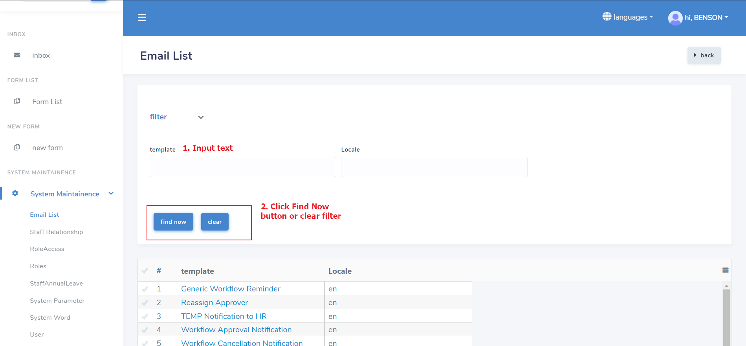

# 2 Personal Details

## 2.1Login

### 2.1.1Normal Login :

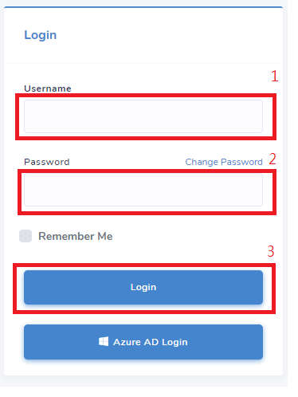

### 2.1.2Azure Login :

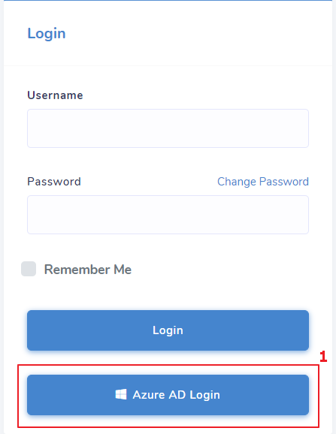

## 2.2 Logout

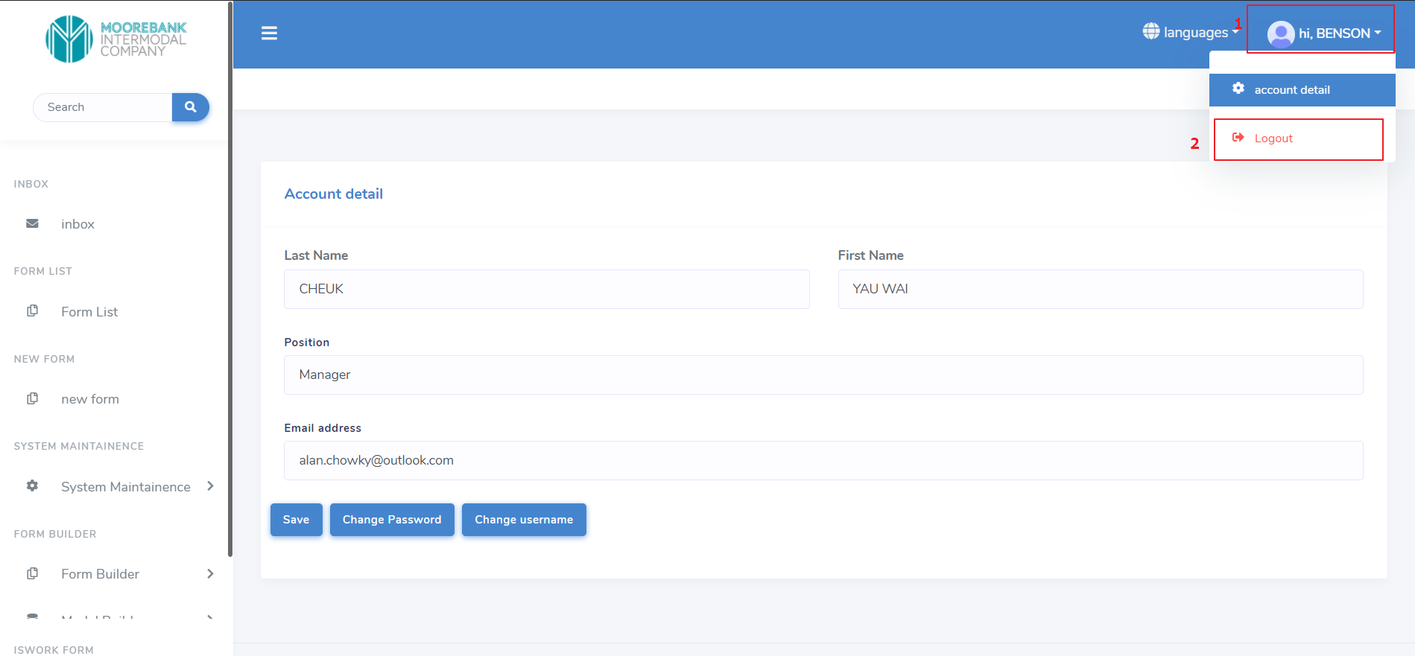

## 2.3 Change Account Detail

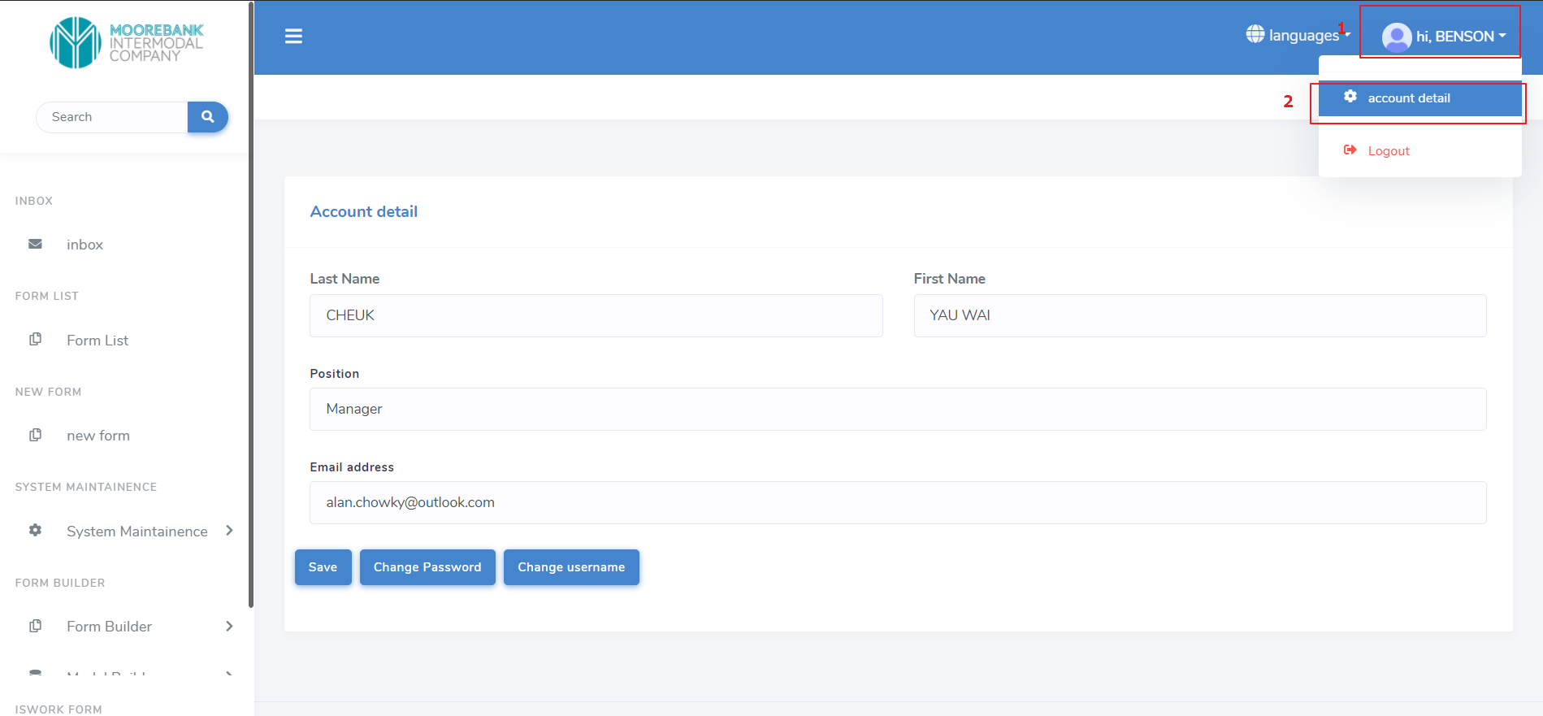

### 2.3.1 General Detail

Input required field and click save

### 2.3.2 Change Password

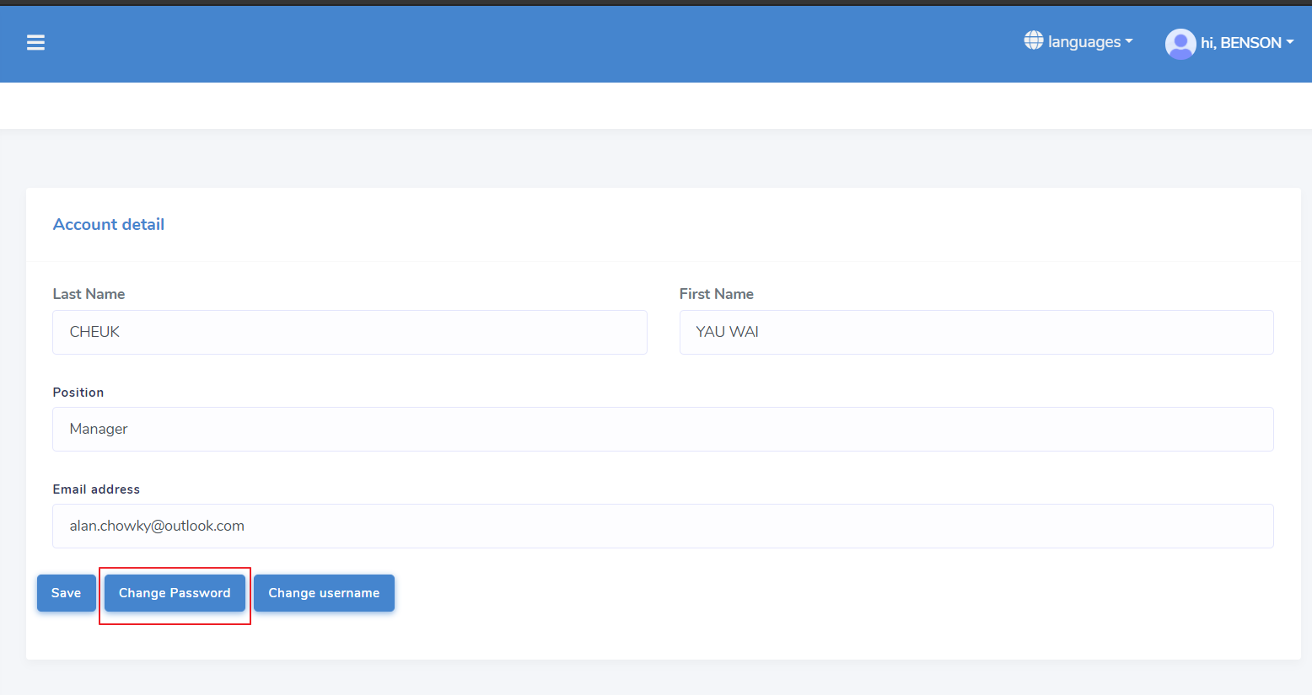

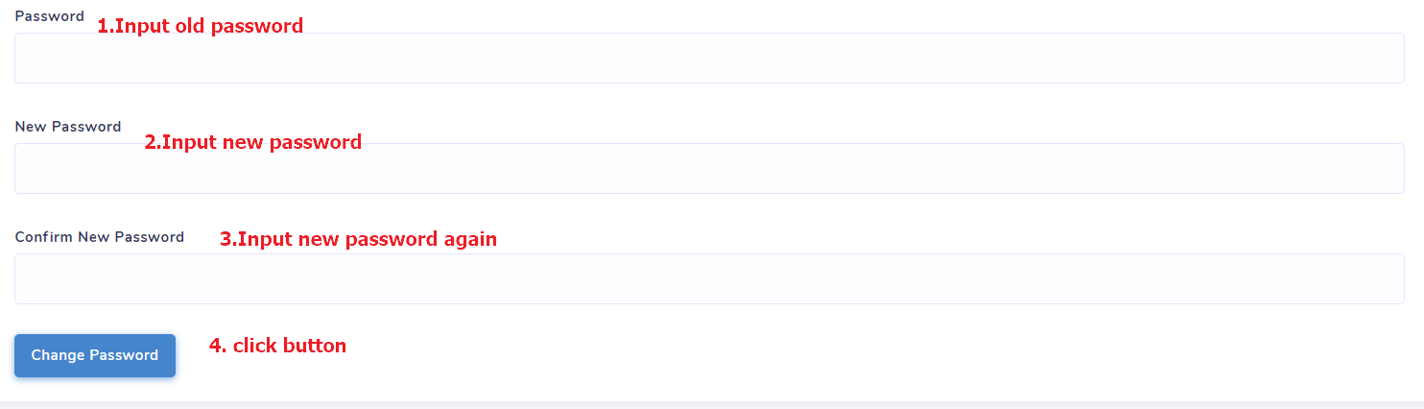

### 2.3.3 Change username

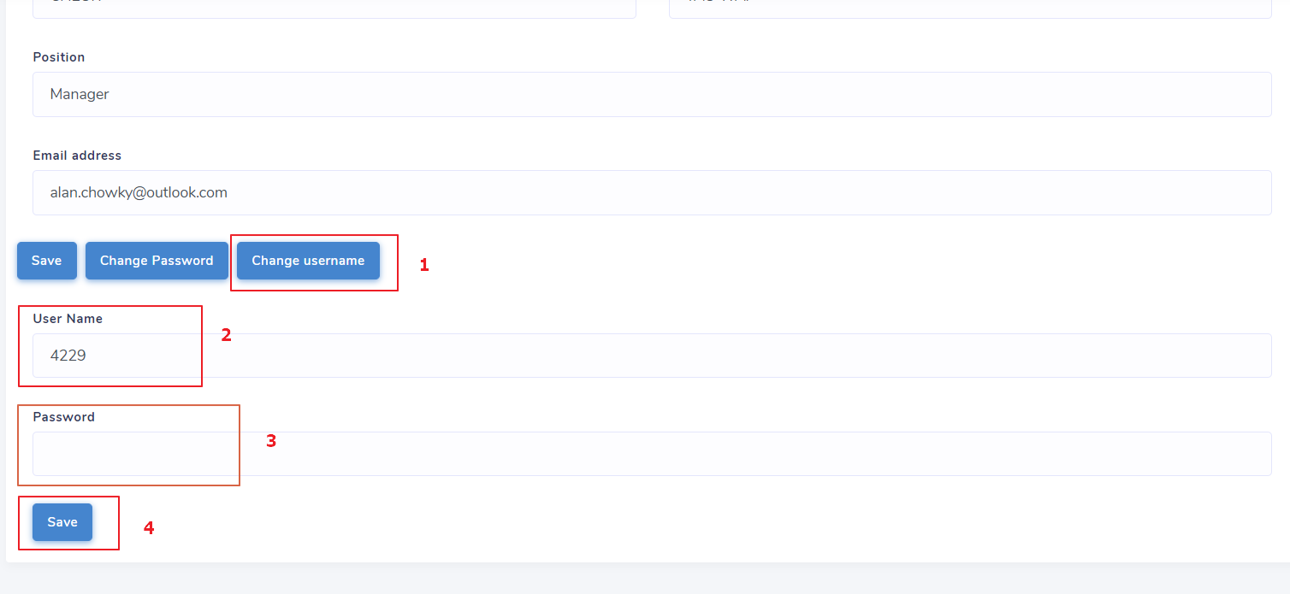

# 3 Builder

## 3.1 Database Model

### 3.1.1 Create Model

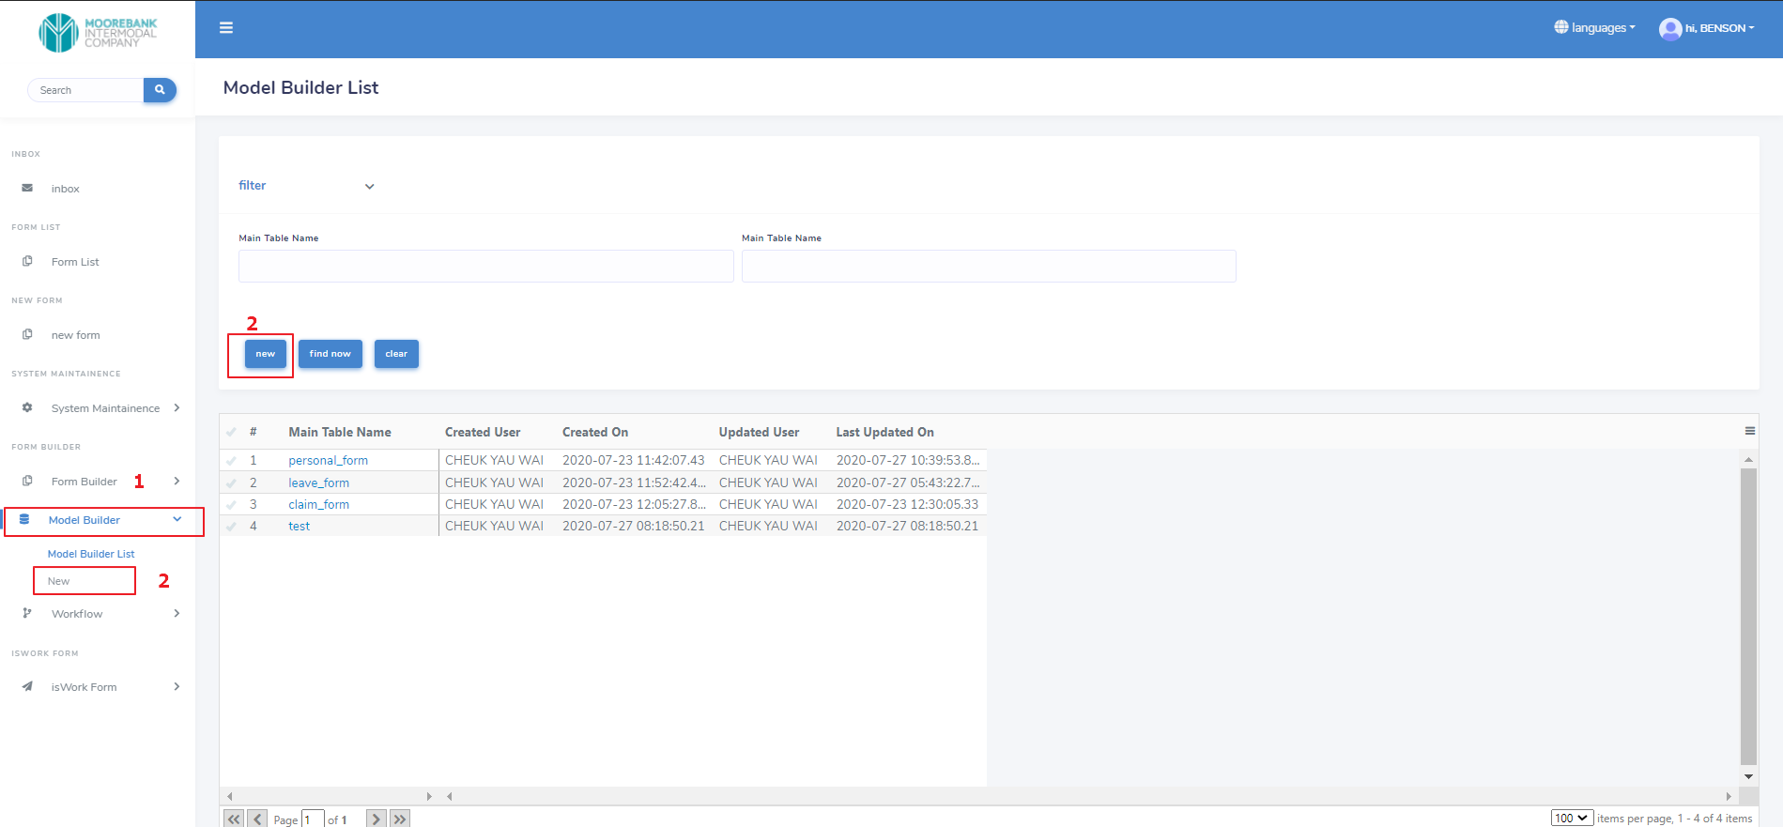

## 3.2 Workflow

### 3.2.1 create new workflow

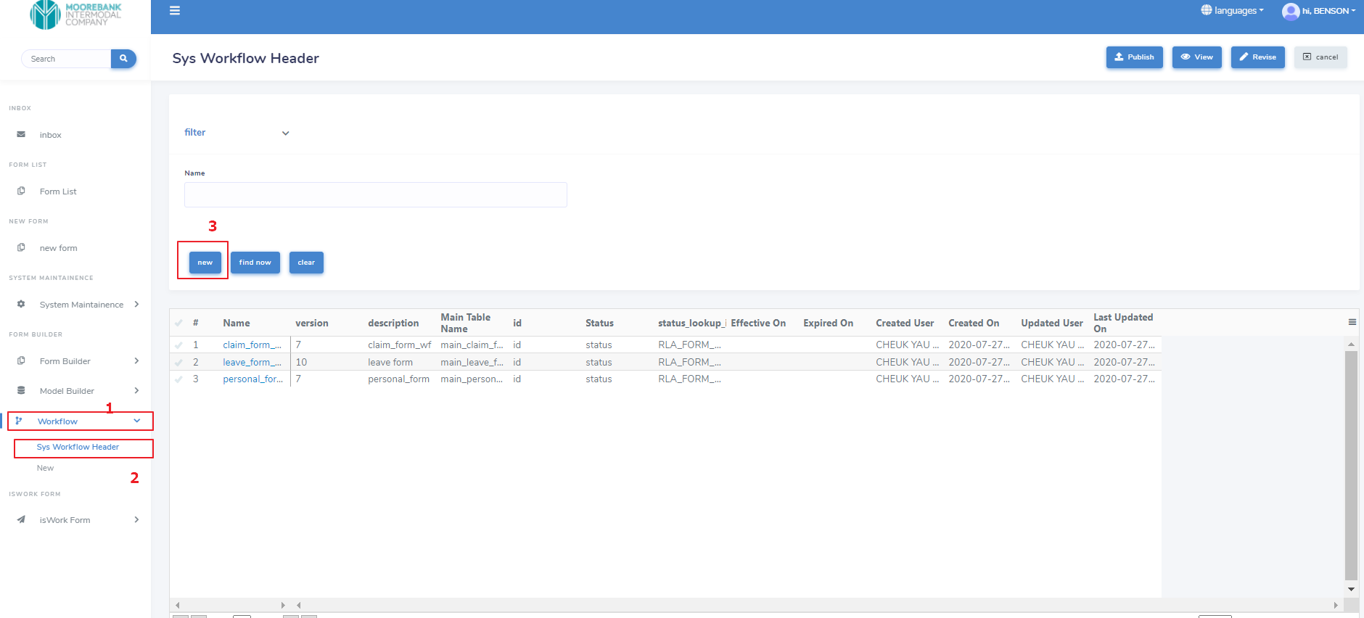

## 3.3 Form Builder

# 4 System Maintenance

## 4.1 Email Template

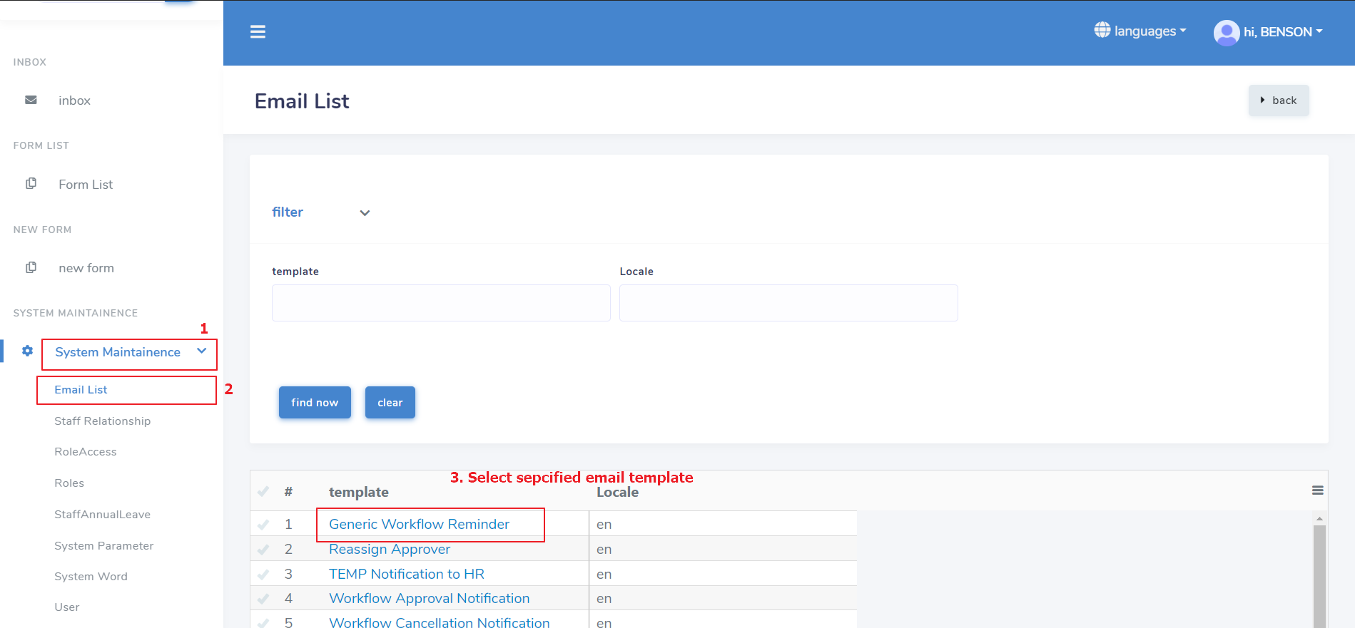

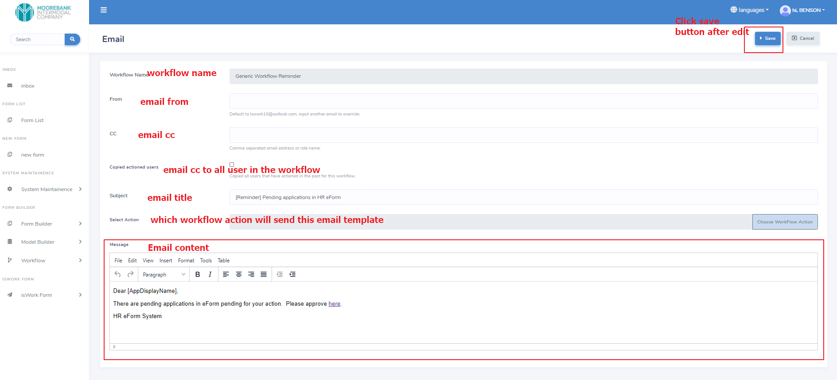

## 4.2 Company Logo

## 4.3 Staff Relationship

## 4.4 Role Access

## 4.5 Roles

## 4.6 Staff Annual Leave

## 4.7 System Parameter

## 4.8 System Word

## 4.9 User

## 

## 

# 5. Test Case

## 5.1 Step of applying a form using Lswork webapp

**1. Go to our demo site. Link:** [**https://lsworkdemo.azurewebsites.net**](https://lsworkdemo.azurewebsites.net)

**Now we will use Rosa Khoury Gebrail’s account to submit a form to Jane Webster. Chris Mottram will be the final approver.**

**2. Login to Your account**

**Username: rosa**

**Password: 1**

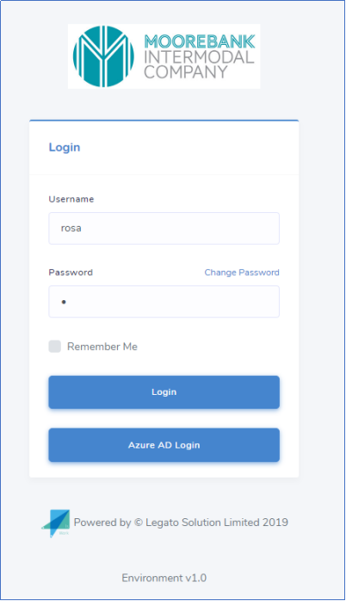

**3. Open Form and click new form**

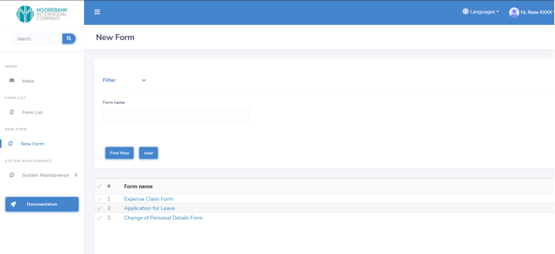

**4. Choose the form you want to create. In this demo we will create Expense Claim Form.**

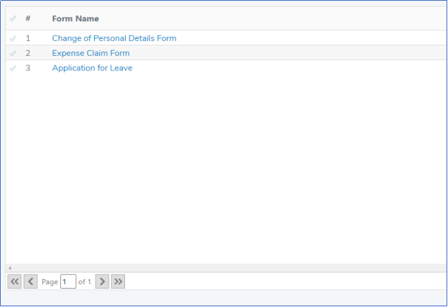

**5. Fill in the form and then click Save button**

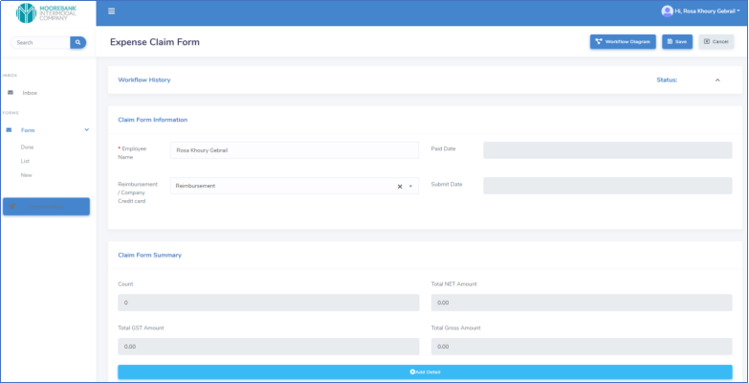

**6. You can see the workflow by clicking the Workflow Diagram button**

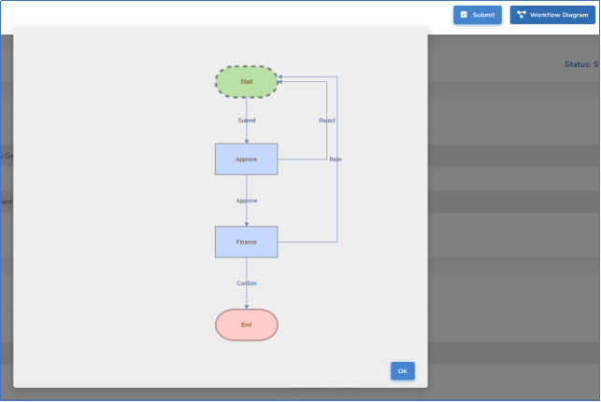

**7. After that, you can submit the form and choose the approver**

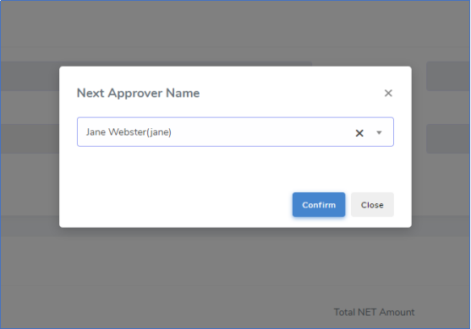

**8. Then, you can open the Workflow History. You will see all the action detail on your form.**

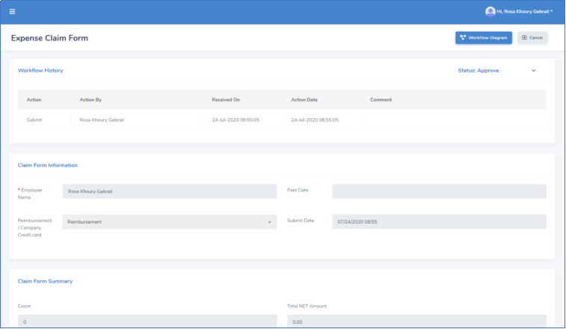

## 5.2. Steps of approve form

**1. Login in to approve’s account**

**Username: jane**

**Password: 1**

**2. You can see the forms submitted to you in the InBox**

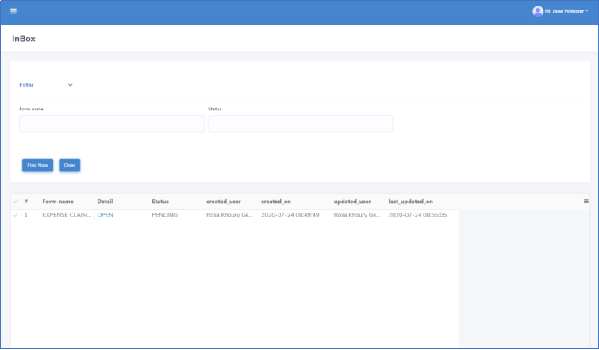

**3. Click the OPEN button in the form list, you can see the detail of the form**

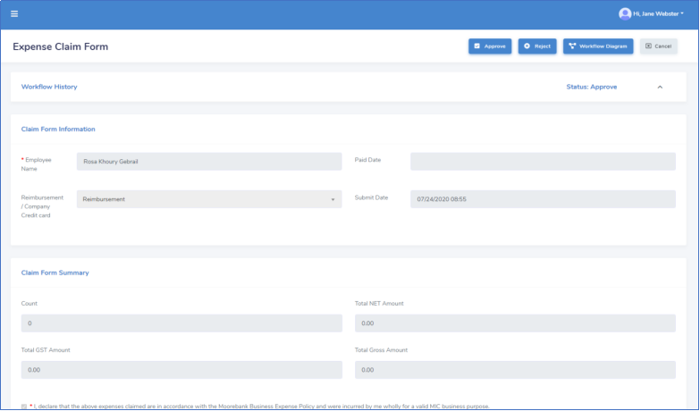

**4. When you click the Workflow Diagram, you can see who submit the form to you**

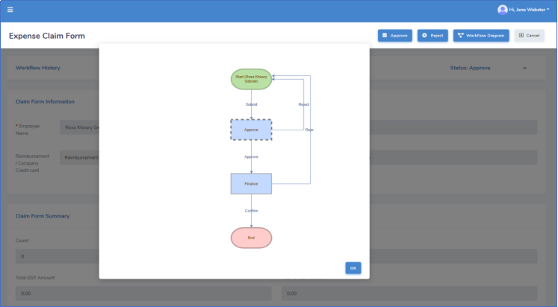

**5. When you want to approve the form application, click the approve button, otherwise click the reject button.**

**6. Then you need to choose the next approver**

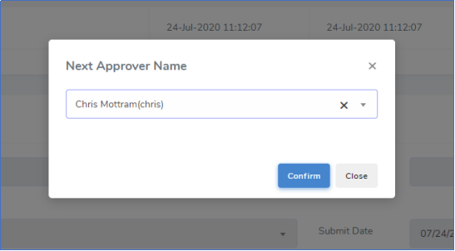

**7. You can also open the Workflow history and Workflow diagram to see the form action detail.**

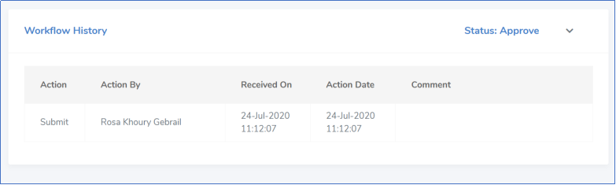

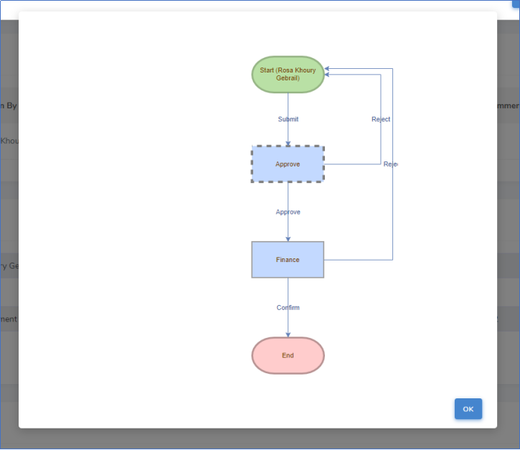

## 

## 5.3 Step of Finance approve

**1. Login to finance account**

**Username: chris**

**Password: 1**

**2. You can see the form in the InBox**

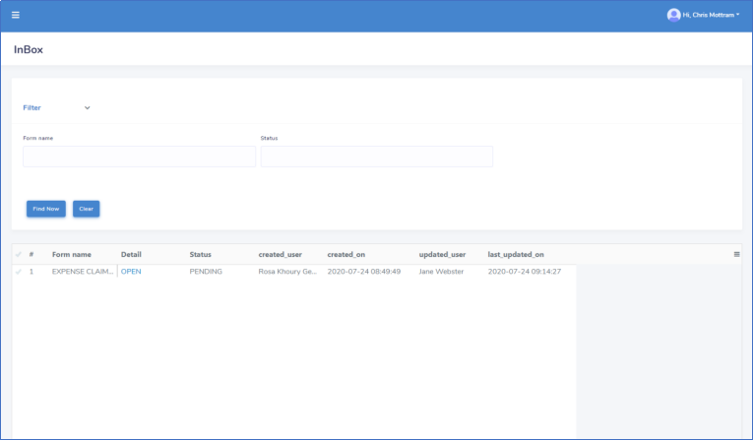

**3. You can see the detail of the form**

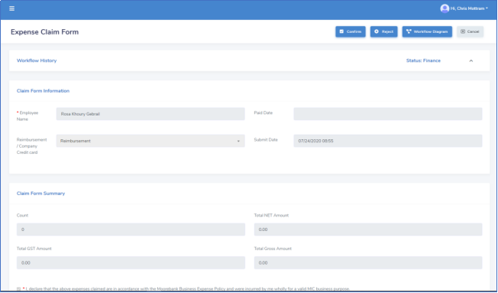

**4. After you click confirm, the whole application process is finished.**

**The applicant can see his application form in Done column after the whole application process is finished.**

